Results

Single cell RNA-sequencing data
To prolife cell-type composition of B6.wt, B6.mdx, D2.wt and D2.mdx muscles, we performed single cell RNA-sequencing (sc RNAseq) on freshly FACS (fluorescence-activated cell sorting)-isolated cells from gastrocnemius muscles dissected from 6-week-old male mice for each genotype.
Filtration control, doublet and ambient RNA removal, gene features, (average number of genes expressed per cell)
Data demultiplexed in fastq format was checked with fastqc and fastq_screen to control quality sequencing. Sequencing reads were processed with STAR (v.2.7.11b) to align and count data for each sample with conservation of rRNA during process. Genome and transcriptome used is GRCm39.111 from Ensembl Database. We counts pre-mRNA overlap gene loci included both exonic and intronic reads where priority is purely exonic alignment (GeneFull_ExonOverIntron option) and spiced, unspliced and ambiguous counts per cell similar to the velocyto.py (Velocyto option). We used output reads statistics (--soloCellReadStats Standard) for each barcode to build our filter thresholds by sample. First, we filtered only barcode where genomeU metrics > 1 and nGenesUnique => 200. Second, we determined the different elbow points along different metrics density by sample with akmedois::elbow_point R function and we selected the minimum of value when the point is tagged “minimum”. At final, tab.1 summarize these thresholds metrics by sample :
 | genomeU* | featureU** | % mitochondrial (mito/genomeU) | ReadsTotal (genomeU/cbPerfect***)
D2-mdx | 14905 | 13024.14 | 12 | 0.39
D2-wt | 66624.09 | 56222.4 | 15 | 0.23
B6-mdx | 15826.45 | 14316.92 | 13 | 0.15
B6-wt | 1159.94 | 12156.24 | 14 | 0.55

* : number of reads mapping to one locus in the genome. ** : number of reads mapping to one feature. *** : number of perfect match on cell barcode.
Third, we determined outliers candidates when used classical outlier detection with this formula
${readsTotal}_{barcode}<\left[Q1\left({readsTotal}_{barcode}\right)−1.5∗IQR\left({readsTotal}_{barcode}\right)\right]$
or ${readsTotal}_{barcode}>\left[Q3\left({readsTotal}_{barcode}\right)+1.5xIQR\left({readsTotal}_{barcode}\right)\right]$
Fourth, we calculated the nuclear fraction (NF) ratio (intronic/exonic) to conserve any barcode with NF>0. Fifth, we powered the percentage of any biotype for each barcode. To identify a “closed” model of integrity cell, we build a covariance matrix with nCount_RNA, nFeature_RNA, genomeU, cbPerfect, mito and percentage of protein coding. Then, we calculated a mahalanobis distance of it and determined outliers barcode when distance pass the pvalue of Chi-square test of independence (x² depending of sample with 7 degrees of freedom). Sixth, we determined Doublet barcode with scDblFinder R packages on cluster-based approach and dbr=0.1. Seventh, we selected any features where mean(count _{sample})_{feature} > 0.1.
In total, 1,297 cells and 17227 features in B6.wt, 6,238 cells and 25779 features in B6.mdx, 1,476 cells and 21026 features in D2.wt and 2,164 cells and 21045 features in D2.mdx were sequenced and used for further analysis.
The downstream treatment for analysis separatly and integrativly after filtering used is SCTransform with glmGamPoi method and a regression of percentage of mitochrondrial, PCA on SCT assay, (s)KNN graph build on pca reduction matrix with a dimensions depending of sample (we selected the last elbow point where cumulative sums of percentage Standard Deviation > 90% and the n+1 dimension not exceed < 1% supplementary), we used Leiden Clustering with igraph method.
For integrative analysis, we build a “group” variable depending of name sample, condition and lineage. We used merge dataset and used JoinLayers from Seurat v5, split merge dataset in function of group value of interest. We performed merged object with the same process before. Before (s)KNN graph building, we used IntegrateLayers with HarmonyIntegration of SCT assay. We build (s)KNN graph on harmony reduction matrix with all dimensions calculated (50). We used Leiden Clustering with igraph method.
For the visualization, we used UMAP as 2 different resolution : 0.2 and 0.8. We used also FFT-accelerated Interpolation-based t-SNE (FItSNE) with this parameters : a modification of initialization (first and second Harmony dimensions are divided by standard deviation of first Harmony dimension multiplied by 0.0001), perplexity_list used is a list starting 30 to nCells_{integrated dataset}/100) and learning rate = nCells_{integrated dataset} / 12, all harmony dimensions used and 1000 iterations to run.
To determine clusters, we compared 2 methodologies :
- manual based on know genes with a strong association with a cell identity
- projection of mkellar, at al. as reference dataset with used FindTransferAnchors and TransferData R function from Seurat.
Biomarkers are identified after PrepSCTFindMarkers on SCT assay and performed with FindAllMarkers with MAST test. We filtered filtered biomarkers to conserve only features |pct.1_{feature/cluster} – pct.2_{feature/cluster} | > 0.2 and p-adj < 0.05. We selected a top5 on each cluster found and sign of log2FC.
CellCycle are performed by tricycle R package.
Pathway annotation are calculated after downloading gmt files from msigdb and raffine geneset depending of dataset tested (we conserve only geneset where 75% of genes are common between geneset and dataset). We calculated a UCell Score with AddModuleScore_Ucell on SCT assay and we determined a smooth signature scores by kNN from Ucell R package.
Integrative analysis of the 4 datasets identified 18 Seurat clusters (Figure 1a). To define each cluster, we first analysed the expression of canonical cell type markers that highlighted 7 hypergroups (Figures 1c, 2a), defined as:
- the muscle stem cells (MuSCs) that include quiescent and proliferating muscle stem cells (MuSCs, Pax7+, clusters 4 and 13) and lineage-committed cells (Myog+, cluster 14),
- the fibro-adipogenic progenitors (FAPs, Pdgfra+, Mme+, clusters 7 and 5),
- the endothelial cells (ECs, Tie1+, Flt1+, clusters 1, 7, 12, 17, and 18),
- the mural cells including the smooth muscle cells (cluster 16) and the pericytes (cluster 11),
- the immune cells (Cd74+, Ptprc+, clusters 2, 5, 9 and 10),
- the tenocytes (cluster 6, Scx+, Tnmd+),
- and the neural cells (Schwann cells, cluster 14, Mpz+, Ajap1+).
Overall, cells for each genotype distribute homogeneously in each hypergroup. Consistent with the inflammation induced by a dystrophic environment, both B6.mdx and D2.mdx muscles exhibit increased proportions of immune cells.

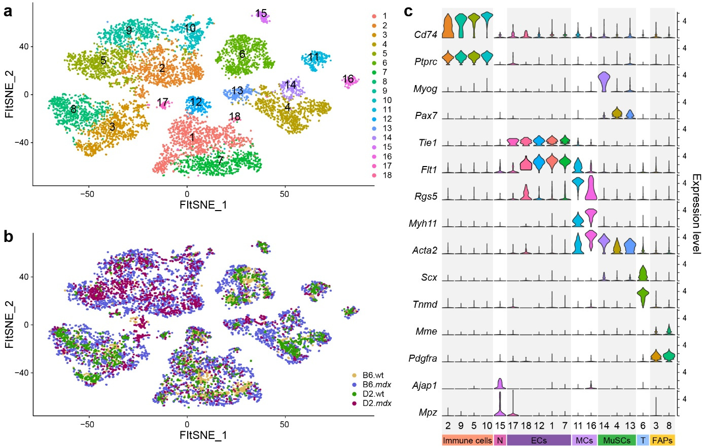
Figure 1: Integration of the 4 single-cell RNAseq datasets. a) Unbiaised clustering of the integrated scRNAseq data represented on FFT-accelerated Interpolation-based t-SNE (FIt-SNE). b) Fit-SNE representation of integrated scRNAseq data where cells are colored by genotypes (yellow, B6.wt; blue, B6.mdx; green, D2.wt; magenta, D2.mdx). c) Violin plots showing the expression of selected canonical genes within each cluster. Cd74 and Ptprc identify the immune cells. Myogenin (Myog) and Pax7 identify the muscle stem cells (MuSCs). Tie1 and FLt1 identify the endothelial cells (ECs). Myh11 and Acta2 identify the mural cells (MCs). Scx and Tnmd identify the tenocytes. Mme and Pdgfra identify the fibro-adipogenic progenitors (FAPs). Ajap1 and Mpz identify neural cells (N).

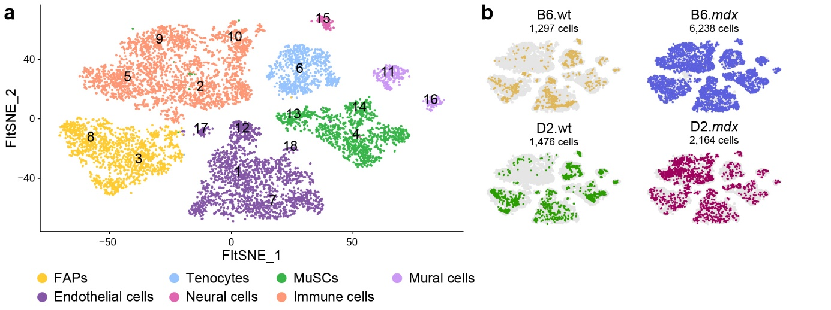
Figure 2: Integration of the 4 single-cell RNAseq datasets identifies 7 main cell types (hypergroups). a) Fit-SNE representation of integrated scRNAseq data. Cells are colored by main types (yellow, FAPs; orange, immune cells; dark purple, endothelial cells; green, muscle stem cells; blue, tenocytes; pink, neural cells; light purple, mural cells) that are defined by selected canonical gene expression. b) Cell distribution for each dataset. Each genotype (wt or mdx) is presented side-by-side for the B6 (top panel) and D2 (lower panel) mouse strains.

Deconvolution of spatial RNA-sequencing data
To estimate the cell type composition at each spatial location

Pseudotime

Methods

Mouse lines
D2.B10 (DBA/2-congenic) Dmd^{mdx} mouse
6-week-old
male
All mice were maintained in a pathogen-free animal facility under standard 12h light/12h dark cycle at 21°C with access to standard chow and water ad libitum. All experiments were performed in accordance with protocols approved by the ethical committee (blablabla).

Single-cell RNA-sequencing library preparation

Spatial RNA-sequencing library preparation
Gastrocnemius muscle from 6-week-old D2.B10 (DBA/2-congenic) Dmd^{mdx} mouse was isolated, embedded in OCT and flash-frozen in liquid nitrogen-cooled isopentane. Embedded muscle was transversely sectioned at 10 µm thickness. 10 µm tissue section was fixed with methanol, stained by hematoxylin and eosin (H&E) and imaged using the Zeiss Axio Scan.Z1 slide scanner. Section was then permeabilized for 18 min (optimal permeabilization time was determined using the 10x Genomics Visium Tissue Optimization Kit). Spatially tagged cDNA libraries were generated following the Visium Spatial Gene Expression 3′ Library Construction Kit (10X Genomics). cDNA library was sequenced in paired-end on an Illumina NextSeq 500. Frames around the capture area on the Visium slide were aligned manually and spots covering the tissue were selected using Loupe Browser software (10X Genomics). Sequencing data were then aligned to the mouse reference genome (mm10) using the spaceranger v1.0.0 pipeline to generate a feature-by-spot-barcode expression matrix (10X Genomics).

